# 

**vignesh lakshminarayanan(A0150251X)**

**DEPARTMENT OF ELECTRICAL AND COMPUTER ENGINEERING**

**EE5201- CONTROL IN DATA STORAGE SYSTEMS**

# **OBJECTIVE:**

The main objective of this report is to provide a literature survey of various modelling techniques and read back signals involved in the design of the perpendicular recording in HDD’s.

This report also gives a clear insight on various models used in the design of the read/write channels used in the hard disk drives. Also, the time and frequency domain models of the perpendicular recording are analyzed in detail.

# **PERPENDICULAR RECORDING IN HARD DISK DRIVES:**

In Hard disk drives, the data is stored in the form of binary digits which are nothing but 0’s and 1’s. Basically in hard disk drives there are two types of recording that are in place. They are nothing but Perpendicular Magnetic recording and Longitudinal Magnetic recording.

# 

HARD DISK DRIVE RECORDING

# 

LONGITUDINAL

MAGNETIC

RECORDING

PERPENDICULAR MAGNETIC RECORDING

Perpendicular Magnetic Recording systems involve the writing process where the polarity of the bits are represented in upward and downward orientation.

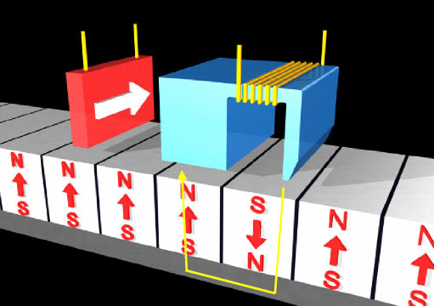



The structure of the PMR media is shown in the below figure. It basically consists of a SUL, interlayer, recording layer and carbon protective layer.

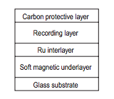

The perpendicular magnetic recording writing process is clearly described in the diagram below. The current in the write head controls the amount of recording flux that has to be generated in the writing process. The amplitude of the write current should be in such a manner so as to magnetize the recording media to saturation. The direction of the write current determines the magnetization of the disk in the appropriate direction.

During the writing process, the disk rotates and bits on the track are written sequentially. The speed of the disk is controlled in an effective way in order to achieve desired bit spacing.

Reading process on the other hand involves the GMR head moving over the track to sense the magnetic field above the medium.

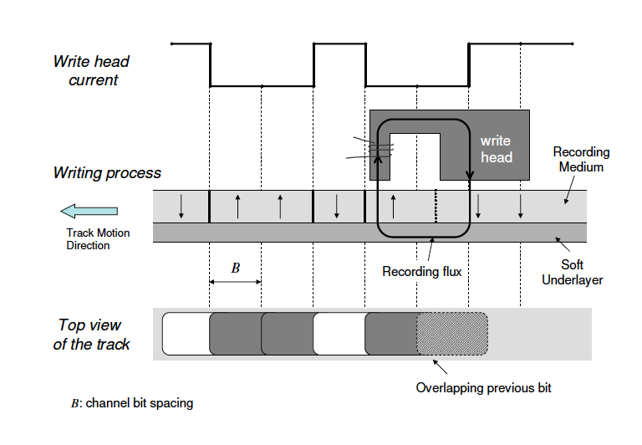

The read back signal is thus a superposition of isolated transient responses at the transitions of the magnetic field. Mathematically the read back signal is given as follows:

*Z(t) = ∑dis(t-iB)*

*Where di=sequence of the transition,*

*S(t)=Transient response,*

*B=Channel bit spacing.*

# **VARIOUS MODELS IN PERPENDICULAR RECORDING:**

**PHYSICS BASED MODEL:**

The physics based model of perpendicular recording can be explained on the basis of the following:

1. Recording media.
2. Read/write head.

For good Perpendicular recording, the media should have the following properties:

The media coercivity should be high, the media should be thicker and the Moment of saturation of the media should be of a higher value.

**READ/WRITE HEAD:**

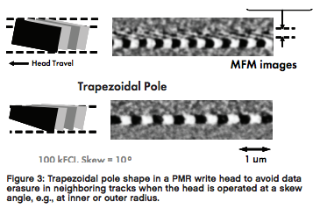

The read/write head used in the Perpendicular recording is shown in the above figure. The main purpose of the Perpendicular read/write head is to generate a magnetic field whose components are higher than the longitudinal components.

The above is being achieved due to the presence of the SUL (Soft Under Layer). The magnetic field is generated from the pole surface instead of the gap and is being collected from the SUL.

**RECORDING MEDIA:**

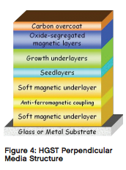**t**

The recording media used in the perpendicular recording is shown above. It basically has a glass or metal substrate on the top of the media followed by soft magnetic layer and other series of layers ending with the carbon coating at the end.

The overall media structure is thus a type of granular media comprising of magnetic alloys such as cobalt, chromium and platinum and an oxide grain boundary sergeant as shown in the figure.

**ANALYTICAL MODEL:**

The relationship between the magnetic properties of recording media and the isolation transition width is determined by the analytical model of perpendicular magnetic recording.

The main assumption behind this model is the value of lorentzian response which is assumed to be with half peak widths and mean values corresponding to the coercive forces of media measured in the direction perpendicular to the medium surface.

In this model there are three axes involved namely X, Y and Z axis. The medium moves along the X-axis and the horizontal component of the head field is given by the equation

*Hh(x,y) = lpha(xo,y).(x-xo)-Hc*

Where *lpha* (x0 ,y) is the head field gradient at the position (x0 ,y) and Hc is the coercive force of a medium

The magnetic distribution *M1(x,y)* is given by the following equation:

*M1(x,y)=M[Hh(x,y)+Hex(x,y)+Hd1(x,y)]*

Where,*Hex(x,y) is mean field expessed as follows*

*Hex(x,y)=* 4∏ß *M1(x,y)*

After head reversal the magnetic distribution is given as follows,

*M1(x,y)=(2Ms/*∏ )tan-1[(x-x0/a1)]

Thus the overall de-magnetizing field is given by the following equation,

*Hd1(x,y)=-4Mz tan-1[(x-x0)/(y-d+a1)]*

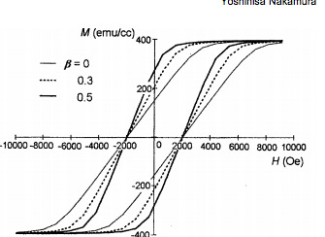

The overall B-H de-magnetization curve is shown in the above figure. It clearly indicates the dependency of ß on M-H curves. The variation of the curve with respect to various values of ß = 0,0.3 and 0.5 is well depicted in the above curve.

**READ-BACK SIGNAL MODELLING OF ANALYTICAL MODEL:**

The 3D analytical model of the read back signal is shown below.The main purpose of this model is to investigate the recorded bit pattern from the different head sensitivity functions.

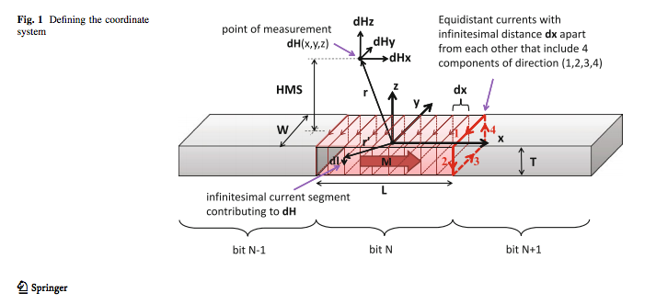

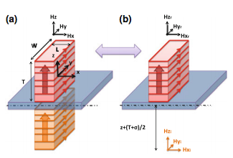

from the above two diagrams it is clear that the Hx and Hy  for both the longitudinal and perpendicular recording is the same and the only difference is the presence of Hz which varies from one recording to the other.

It is described below in the following equation

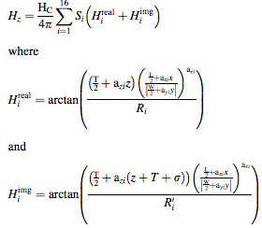

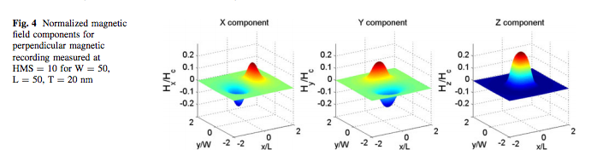

The Hx, Hy and HZ values of the perpendicular magnetic recording for recording media having Length=50nm,Width=50nm and thickness=20nm is described in the above figure.

TIME DOMAIN AND FREQUENCY DOMAIN MODEL OF PERPENDICULAR RECORDING:

The time domain analysis and frequency domain analysis of the readback signal from the Karlqvist head and the recording medium of a perpendicular magnetic anisotropy is analyzed using the signal processing criteria as described below:

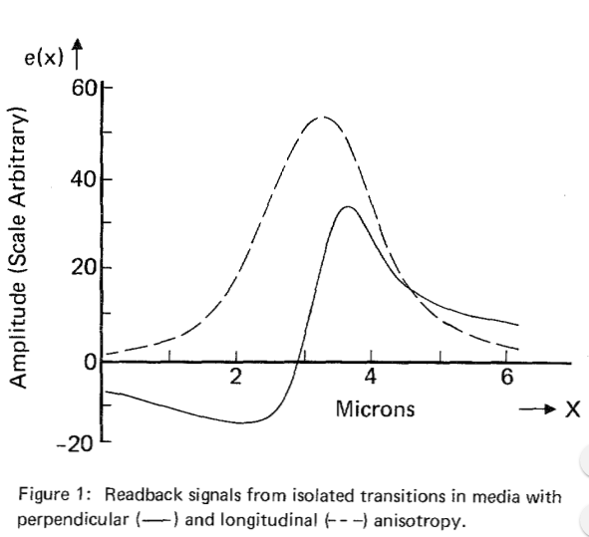

*BI-MODAL PULSE*

The above graph compares the readback signal from the isolated transitions in media from both the perpendicular and longitudinal anisotropy.The longitudinal recording produces an uni-modal pulse whereas the perpendicular recording produces an asymmetric bi-modal signal.

The sharp rise-time or fall-time of the bimodal pulse contains the information of clocking and detection of the encoded information.

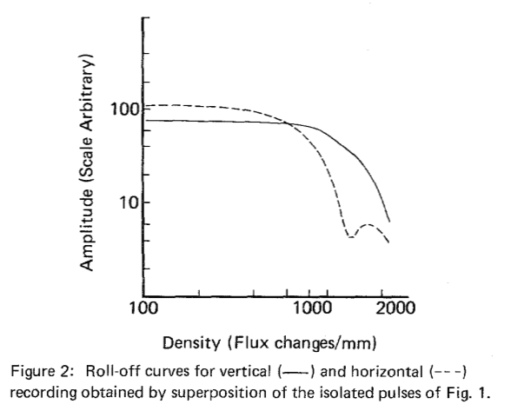

The roll-off curves of both longitudinal and perpendicular recording is shown above.

The roll-off characteristics of the perpendicular magnetic recording is better than that of the longitudinal recording.The main reason behind it is due to the formation of bi-modal pulse and not because of the narrower transition region in perpendicular recording.

Considering the magnetization of the media to be M and head sensitivity of the media to be H, the readback voltage of a recording channel for a thin medium in the frequency domain is described below:



The net magnetization can be represented in the below equation:



The overall resultant voltage in the time domain can be expressed as in the below equation:

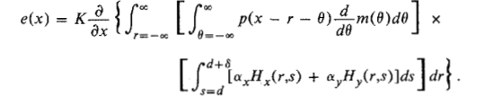

In the frequency domain, the above equation can be re-written as follows:

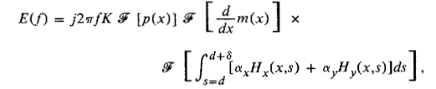

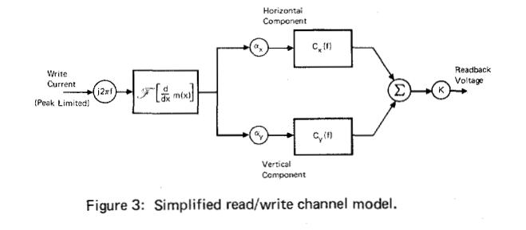

The simplified read/write channel model is shown in the above diagram. The linear combination of horizontal and vertical head sensitivity function and the read back voltage is the summation of the horizontal and vertical component.

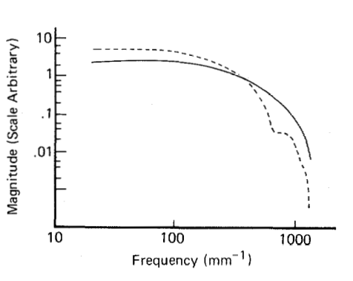

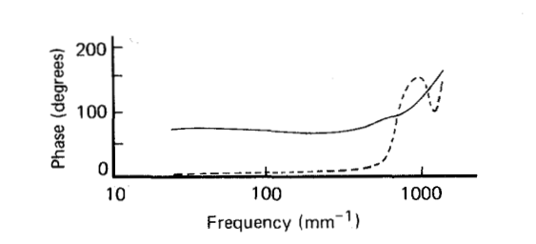

The frequency response of the longitudinal and perpendicular magnetic recording is graphically depicted in the above figure.

The magnitude response of both the perpendicular magnetic recording and longitudinal magnetic recording are similar. But the phase response of the two are not constant over one particular frequency band.

**MATLAB SIMULATION OF TIME AND FREQURENCY RESPONSE:**

The transient impulse response of the time domain model can also be described using the arctan function

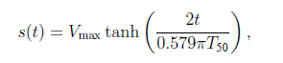

Where Vmax is the zero to peak amplitude and T50 is the width when s(t) changes from –A/2 to A/2.

At T50/2 -> s(T50/2) = A/2

For this simulation we assume the following values,

A=2 units

Tb=20 units

T50=Tch=30 units

MATLAB CODE:

close all;

clear all;

clc;

%parameters initialization

count = 1;

A = 2;

Tb = 20;

T50 = 30;

%% Computation of Impulse Response

for t = -100:0.1:100

impulse(count) = A*tanh(2*t/(0.579*pi*T50));

count = count+1;

end

plot([-100:0.1:100],impulse);

%Compute s(t-Tb)

delayed_imp = [-A*ones(1,Tb) impulse];

impulse = [impulse A*ones(1,Tb)];

%% h(t) computation

dibit1 = (impulse - delayed_imp)/2;

dibit = dibit1;

figure

plot(dibit);

xlabel 'time ', ylabel 'Magnetic field'

title('Dibit Response of perpendicular recording');

chnl_freq_resp = fft(dibit);

%% Frequency response LPF

figure

axis([0 100 0 100]);

plot(abs(chnl_freq_resp(1:80)));

xlabel 'frequency ', ylabel 'Channel response'

title('Frequency response of perpendicular read/ write channel');

The expected frequency response is a narrow Low pass filter as shown below

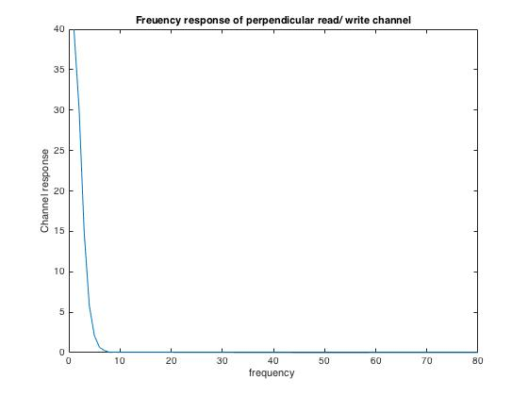

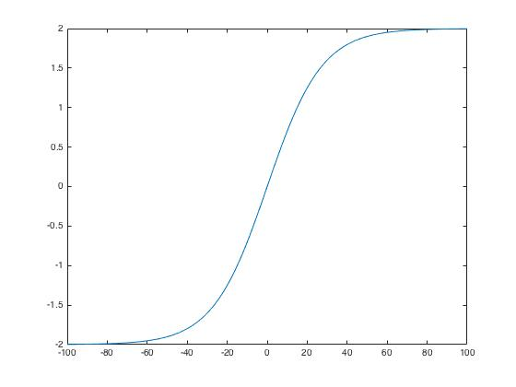

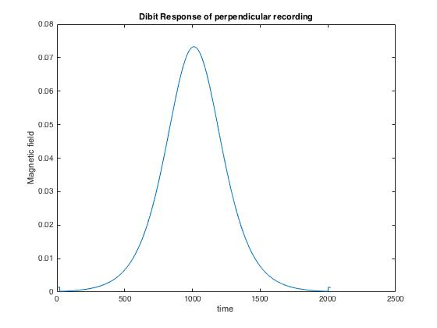

CONCLUSION:

Thus, literature survey of various modelling techniques involved in the Perpendicular magnetic recording is clearly described in detail.

REFERENCES:

[1] PROCESSING OF SIGNALS FROM MEDIA WITH PERPENDICULAR MAGNETIC ANISOTROPY B. J. LANGLAND and M. G. LARIMORE

[2]UNIVERSITY OF CALIFORNIA ,SANDIEGO channel modelling ,signal processing and coding for perpendicular magnetic recording

[3]Analytical model for estimation of isolation transition width in perpendicular magnetic recording